

Software design

Task 1



Adnan irfan

[4067 CEM]

**The idea of this project** is to create a Buddy application for the students to communicate and interact with each other and make new friends. **The target audience** for this application are the students of INTI College Penang. But before the application was created, it was necessary to know what the students thought about this plan. A Google form was created to know what was on their mind, and if they would like such an application. Below are the questions that were asked along with the responses students submitted.

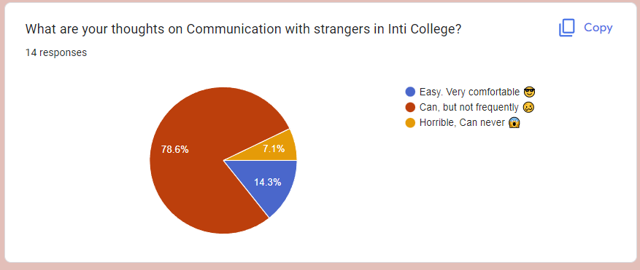

Figure 1.1 Pie-chart showing what people think about interacting with others

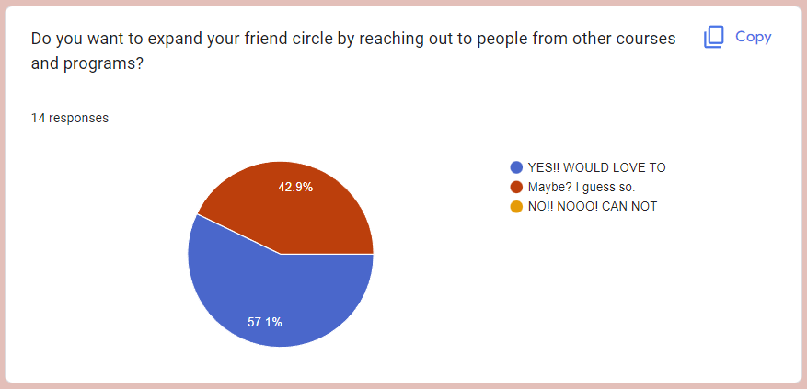

Figure 1.2 Pie-chart showing the thoughts of people on expanding their friend radar range and know more people

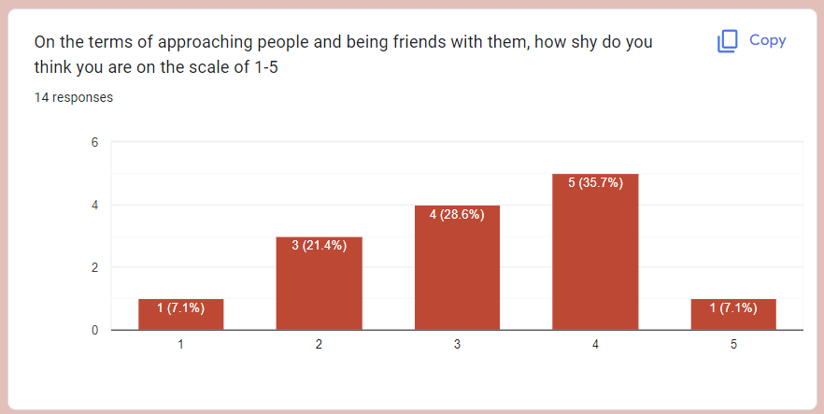

Figure 1.3 Bar graph representing how many people are shy and how many are open-minded and free to talk

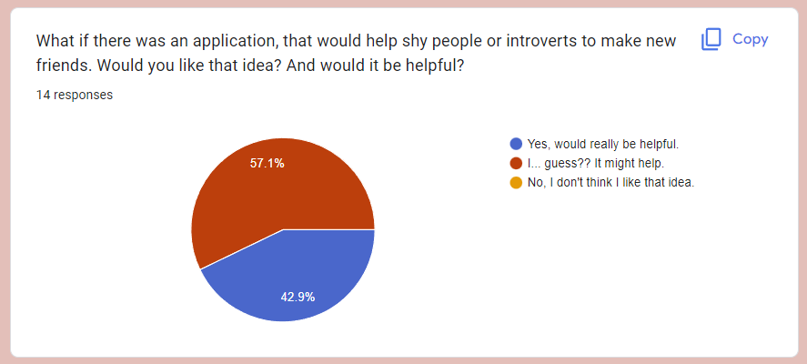

Figure 1.4 Pie-chart depicting information about what people think about the idea of having an application to interact with people

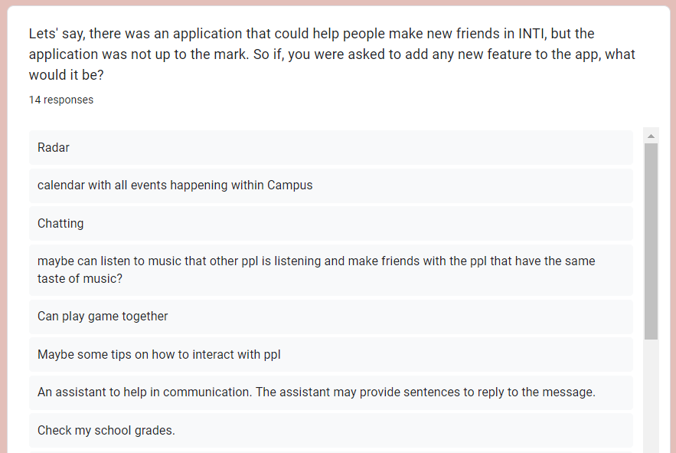

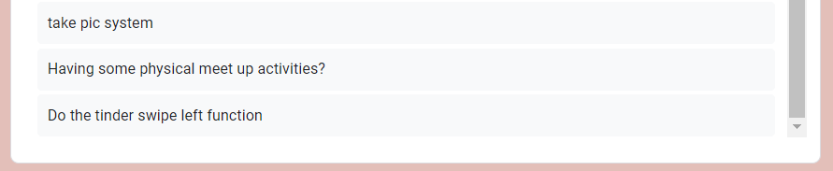

Figure 1.5 this question shows the responses of students on what features they would like in the Buddy application

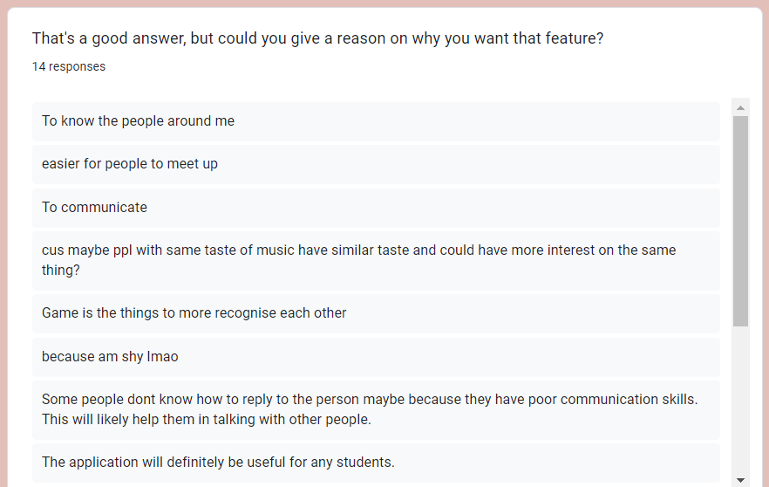

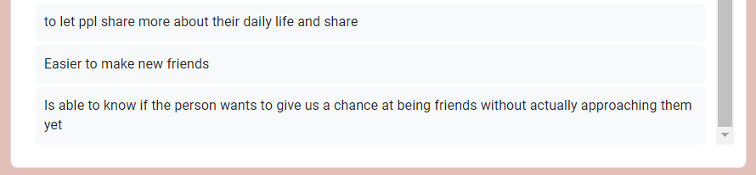

Figure 1.6 this was another question where the student was made to write about the reason on why they wanted the feature they mentioned earlier

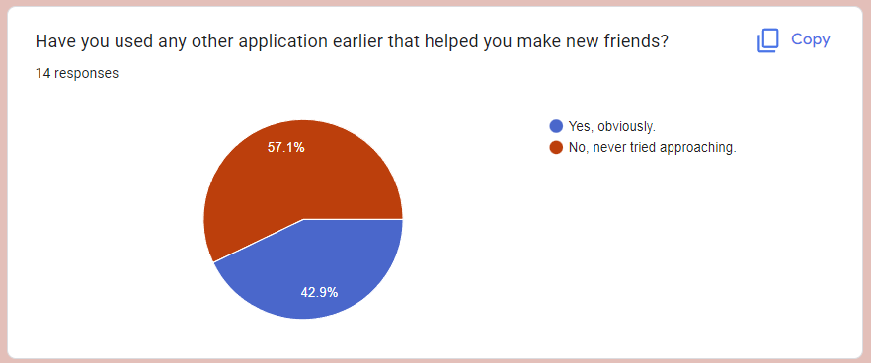

Figure 1.7 Pie-chart to get the general idea if students have used any other application to communicate or interact with others

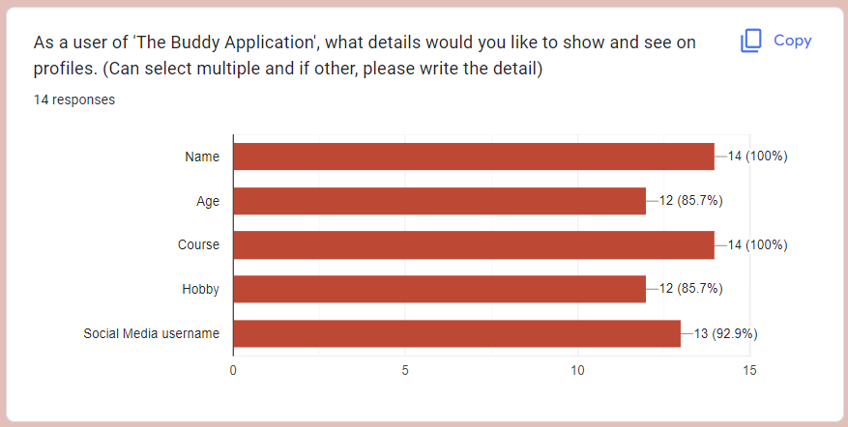

Figure 1.8 A graph representing what all information do the students want on their profile and what information they would like to see on a buddy’s profile

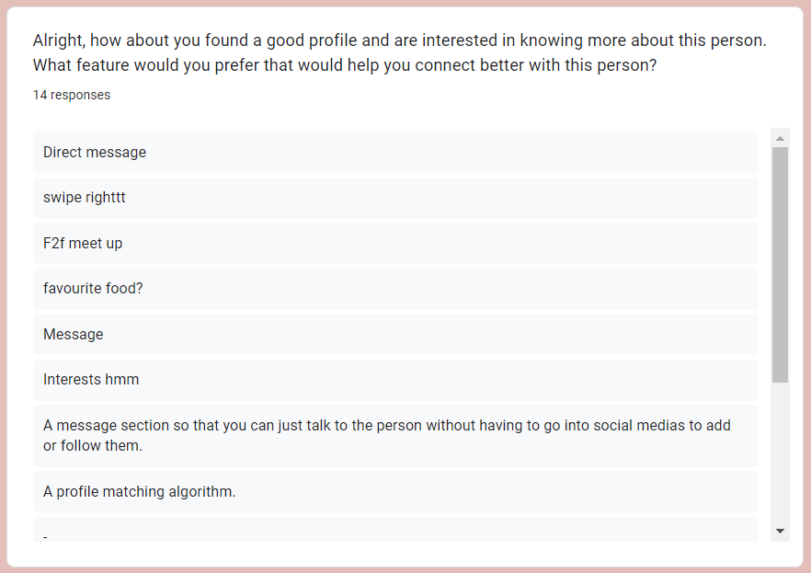

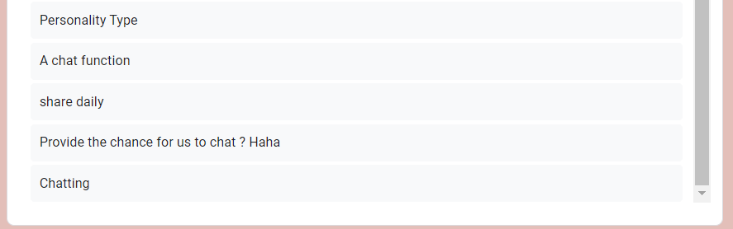

Figure 1.9 Another Question that was asked to the students, where they had to answer on how would they like to connect with their respective buddy if they found them interesting

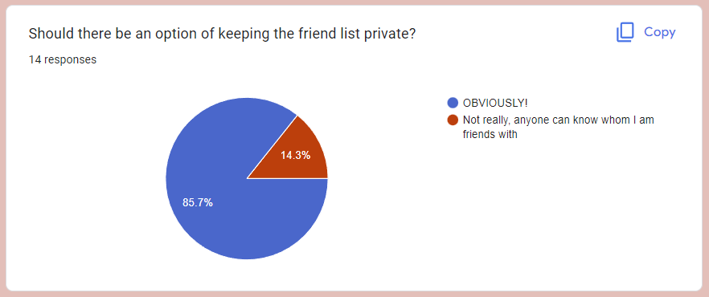

Figure 1.10 The last question and the pie-chart depicts on how many people would want their friend list to be private/public

Summary to the Google form –

After analyzing the survey form, it was noticed that even if there were people who were shy to talk and communicate with others, they would like an application which would assist them in making new friends. This shows how students need a helping hand, and this application ought to give them that. As per the responses students liked the idea and were also able to give valid suggestions and feedbacks for its functionality.

User Story Mapping

To create the final product (i.e. the Buddy Application), a user story map had to be created, which would help in understanding and knowing all the necessary tasks, and which tasks were to be prioritized. Below is the representation of the Story Mapping which tells about what the main goals are

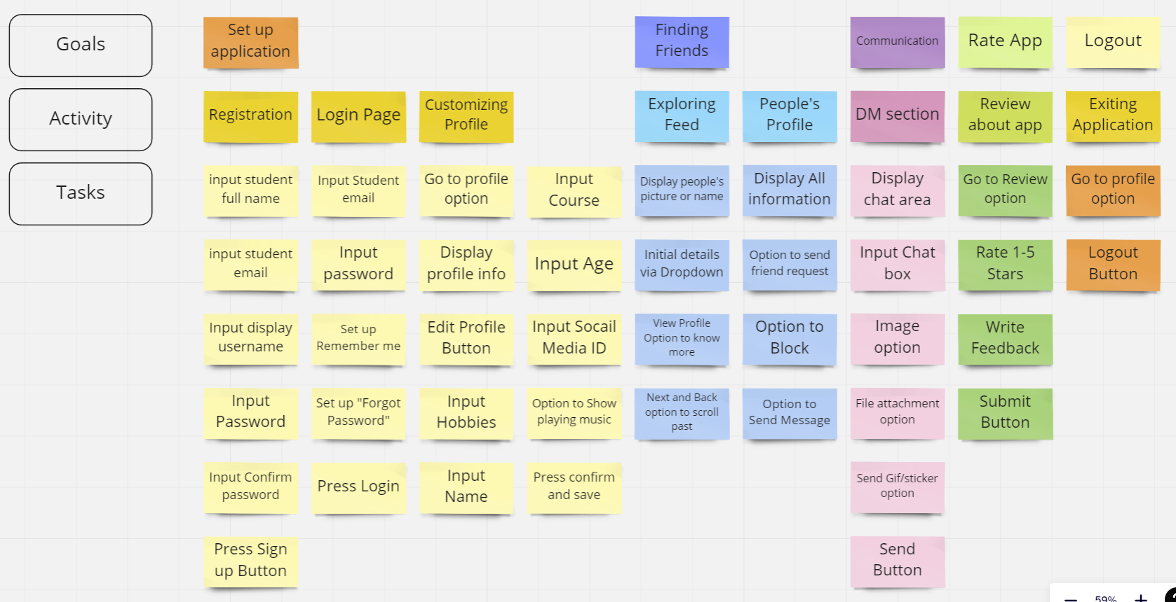

Figure 1.11 User Story Mapping for the Buddy Application